Hello again. Hope you are all fine. I am sending you the best season’ s greetings.

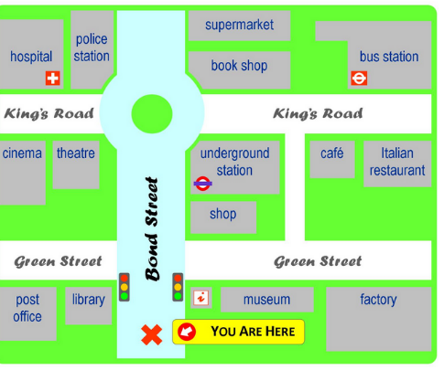
Class B Beginners, Giving directions ( worksheet 5)

- Do the preparation online exercise before you listen to see if you know the vocabulary.( Click online)
https://learnenglishteens.britishcouncil.org/skills/listening/elementary-a2-listening/giving-directions
- Then, look at the map and listen to the directions .Click the link below.
https://learnenglishteens.britishcouncil.org/skills/listening/elementary-a2-listening/giving-directions
- Do the other online exercises. .Click finish to see your score.
D. Now read the instructions.
A. Go straight on. Then take the first left on to Green Street. Walk past the library and it’s the building next to the library on the left.
B. Go straight on. Go past the traffic lights. You will see a shop on the right. Go past that and it’s on the right next to the shop
C .Go straight on. Go past the traffic lights and go straight on until you get to the roundabout. At the roundabout turn left. Go past the theatre. It’s the building next to the theatre, opposite the hospital.
D.Go straight on. Go past the traffic lights and take the second right on to King’s Road. Go past the bookshop. It’s the building next to the bookshop opposite the café

I hope that you can give directions now if somebody asks you:
Excuse me, how can I get to the…..,please? or Can you tell me the way to…..?
(Thank you for working again. You don’t have to send me anything back this time.)

